PF Lab 06 Tasks

Name: Muhammad Sarim Abidi

Roll No: 25K-0090

Section: BAI-1A

Task 1:

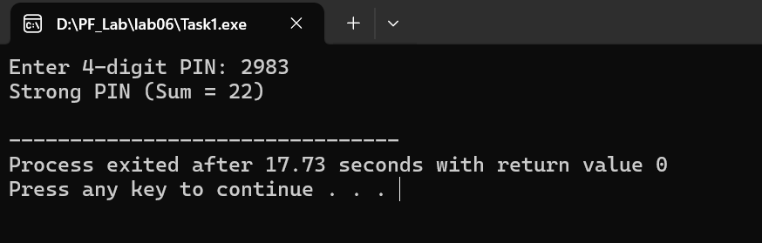

Task 2:

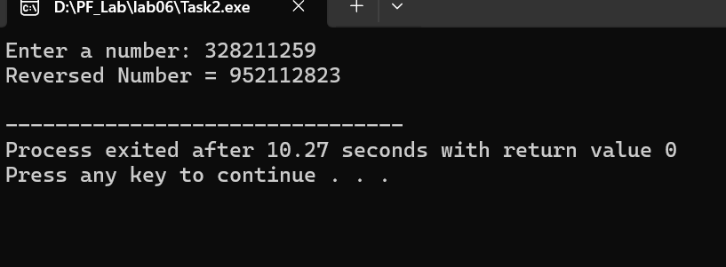

Task 3:

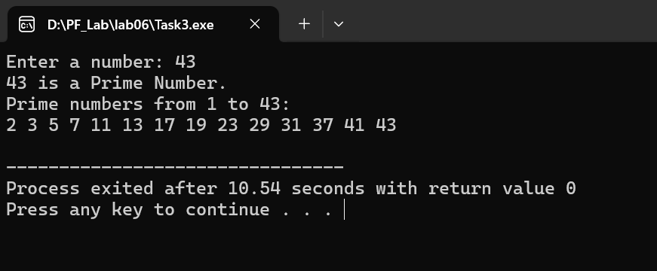

Task 4:

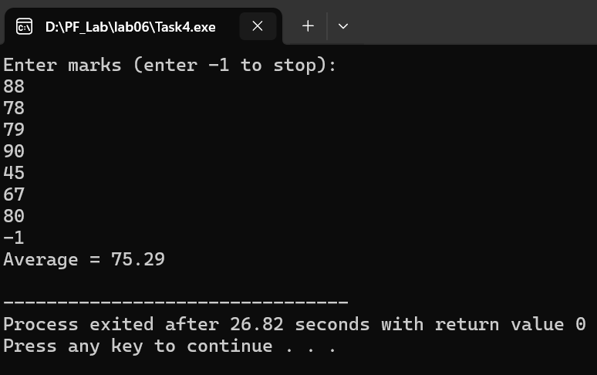

Task 5:

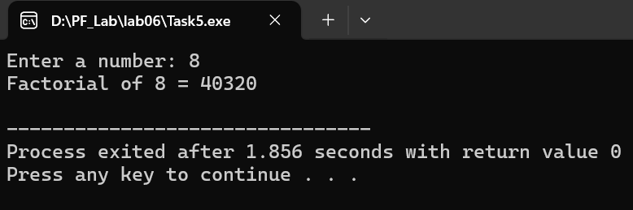

Task 6:

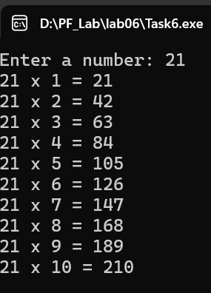

Task 7:

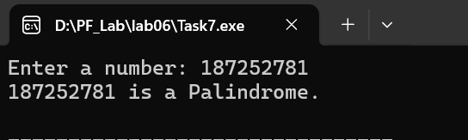

Task 8:

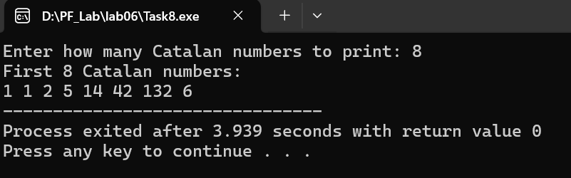

Task 9:

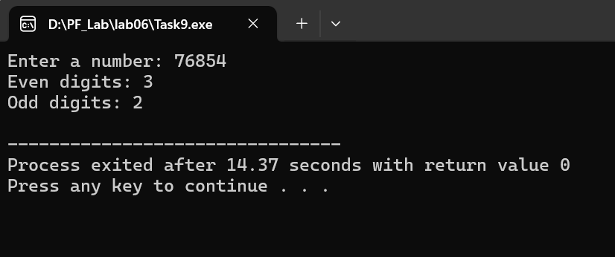

Task 10:

